School Gate debate: is Oxford University sexist?
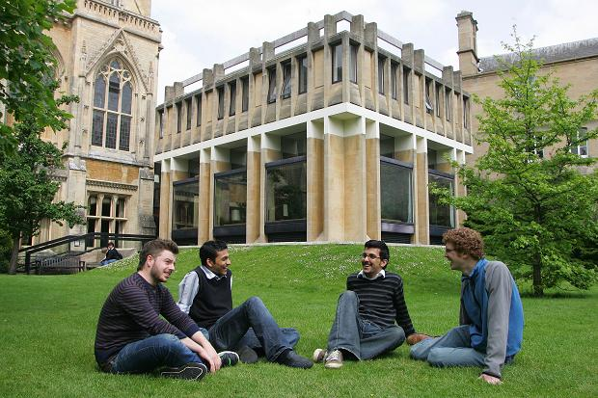
Sarah Ebner
June 29 2010
It’s one of the top universities in the world, but are the women who go there disadvantaged?

I didn’t go to Oxford myself, so don’t feel that I can make any categorical yes or no on this one. However, I was initially inspired to ask this question by two things I’d read. One was Naomi Alderman’s book, The Lessons, which has strong Brideshead Revisited overtones and is about a group of friends who meet at Oxford. The other was an interview with actress Alice Eve.In Naomi Alderman’s book, there is a definite sense that women come off worst at the university. Of the group of friends in the book, she writes: “Emmanuella received a lower second, while Simon got an upper second, and none of us could ever account for this except that it seemed often to be how things happened between men and women at Oxford, the men appearing to be marked with slightly surprising leniency, the women with surprising strictness.”

Meanwhile Alice Eve told the Sunday Times that while she loved Bedales and Westminster, she didn’t like Oxford. She added: “It can be sexist. They don’t really cater for the female mind, which is a bit different to the male mind. Mine is, anyway.”Can this really be true? After all these years, and all these successful Oxford graduates, is there still a sense that women get a raw deal?
Katharine Halls, a member of the Oxford University Women’s Campaign, is in her third year at Oxford. She says that applications to the university from women are falling (in fact, the number of female undergraduates has fallen, from 43.2 percent in 2006 to 42.6 percent in 2009) and isn’t surprised by that.“There’s something within Oxford’s reputation which puts people off,” she explains. “There’s still a strong class environment in Oxford and it can be a bit daunting. The university has got this reputation for being full of posh boys, and that’s true, even though there are a lot of other people there too. I am really disappointed by how homogenous the population is.”

Katharine feels that Oxford is an “elitist” institution which reflects other inequalities too (such as the under-representation of state school pupils and ethnic minorities). But she also feels that part of the problem might be that women (especially those, like herself, who didn’t attend private schools) may be less pushy. And she’s sure that there are extra pressures on women due to Oxford’s traditions of balls and formal dinners. Katharine has also been unimpressed by what she terms some “archaic traditions”.“Some things are really shocking,” she says. “If a woman wants to be elected to her JCR [junior common room] for example, she might have to do a fake striptease or give the male head of the JCR a fake blow job.”

Author Naomi Alderman attended Oxford in the mid 1990s and she says she didn’t expect to encounter sexism. “No, I really didn’t,” she says. “I had come from an all-girls school where the teachers were very supportive and interested in the girls. I didn’t really know what sexism was - or it seemed like the kind of thing that uneducated people did or thought - I arrived thinking that I would of course be treated perfectly equally.” But Naomi says this wasn’t always the case. “Certainly there were some individuals who were especially bad - it was well-known that there were some tutors who refused to teach women students. (This came as a bad shock to me - it wasn’t what I was expecting from Oxford at all.) At the time I was there, the undergraduates were 2/3 men, 1/3 women. Given that what Oxford says about itself is “we only take the best of the best”, this rather implied that there were more clever men than clever women. I remember being quite stunned by how individual tutors could get away with pretty shocking behaviour to female undergraduates and be given just a rap on the knuckles - I suppose that’s ‘institutional’ rather than ‘individual’. “

Before this is all dismissed as griping, there is definitely a gender gap at Oxford. As Mary Ann points out in her article, more men than women get firsts, and there are also far more male professors than female. Why is this?
Dr. Armand D’Angour is a fellow and tutor in Classics at Jesus College, Oxford, and also a Schools Liaison Officer. He says he is “sorry” to hear that some female students still find Oxford sexist, but adds: “Oxford is bound to have pockets of sexism, though it is not “institutionally’ sexist, and undoubtedly less so than British society in general, as you would hope and expect from an enlightened academic institution (I suspect the students may be less enlightened than the academics, in fact).”

Marta Szczerba is currently in her second year at Oxford reading PPE. She’s also reluctant to claim that Oxford is sexist, but admits that there are problems with certain of the university institutions (and so, the students!)
“For example,” she adds. “In the Oxford Union elections women are often accused of “sleeping to the top” and judged by their looks when people vote for them. The position of Secretary has legendarily been judged by “who looks prettier in the chamber”. At the Oxford Gossip forum, some girls are called sluts. However, this problem is being worked on with the Oxford Union’s “Women’s Initiative” and the recent election of Laura Winwood, who was the 21st woman out of 500 Presidents.”

Marta herself says that she hasn’t experienced sexism, but points out some interesting facts. For example, St Hilda’s, once an all-female college, now welcomes men. As soon as this happened, it moved to an all-male executive.
But James Kingston, current President of the Oxford Union says that the students aren’t to blame. He argues that huge attempts are being made to involve more women. “Due to the nature of Oxford, when you walk into various places, the faces staring down at you are often male, but efforts are being made to redress the balance. It’s not a question of sexism, but more a weight of tradition. In the Union, we simply look for people who are talented and popular.” Naomi Alderman says that when she was at Oxford it “was probably somewhat harder to be a female student than a male one.” But she adds (and it’s the same point which Katharine Halls was making) “that’s only one of several kinds of difficulty: I’m sure it was also harder to be a black student than a white one, or a Muslim student than a Christian.”

